Lab Assignment 4

Name- Aye Myat Thiri Khin

ID-20293

**Q :** Design the following 2-bits RTL level combinational logic modules in continuous assignment and always blocks for each gate and write the testbench to verify your design covering all the testcases by showing the waveforms,

* 1. 1-bit NOT gate
  2. 2-bits AND gate
  3. 2-bits OR gate
  4. 2-bits NAND gate
  5. 2-bits NOR gate
  6. 2-bits XOR gate
  7. 2-bits XNOR gate

Ans:

(1)

1. bit NOT gate

module not_gate (

input a,

output y

);

assign y = ~a;

endmodule

module test_not_gate;

reg a;

wire y;

not_gate uut (

.a(a),

.y(y)

);

initial begin

$dumpfile("not_gate.vcd"); // For VCD waveform generation

$dumpvars(0, test_not_gate);

// Test all input cases

a = 1'b0; #10;

a = 1'b1; #10;

$finish;

end

endmodule

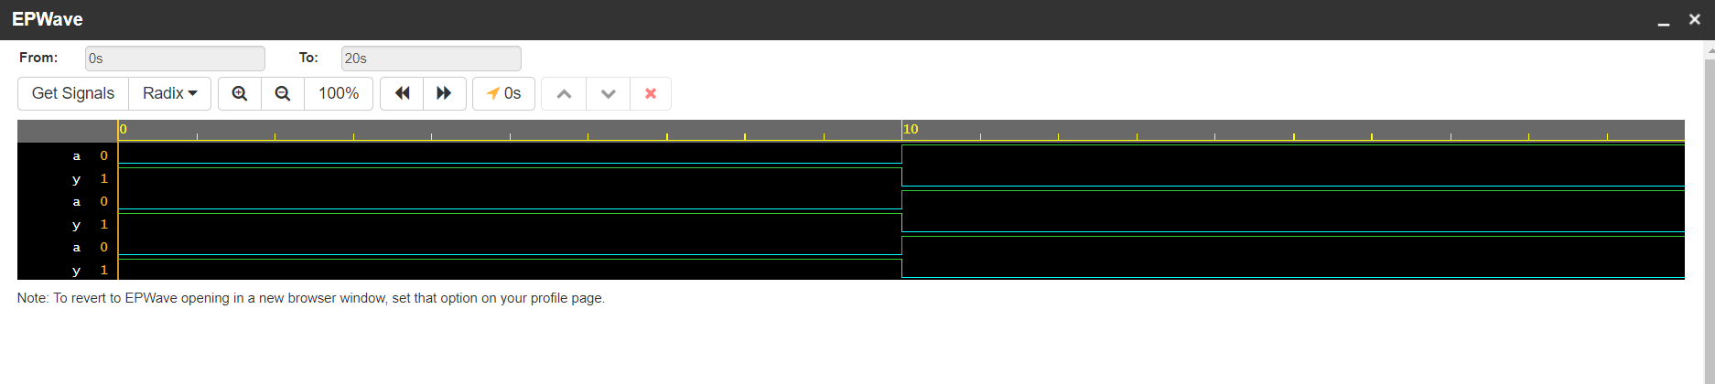

(2)

1. bits AND gate

module and_gate_2bit (

input [1:0] a, b,

output [1:0] y

);

assign y = a & b;

endmodule

module test_and_gate_2bit;

reg [1:0] a, b;

wire [1:0] y;

and_gate_2bit uut (

.a(a),

.b(b),

.y(y)

);

initial begin

$dumpfile("and_gate_2bit.vcd");

$dumpvars(0, test_and_gate_2bit);

// Apply all input combinations

a = 2'b00; b = 2'b00; #10;

a = 2'b01; b = 2'b01; #10;

a = 2'b10; b = 2'b10; #10;

a = 2'b11; b = 2'b11; #10;

$finish;

end

endmodule

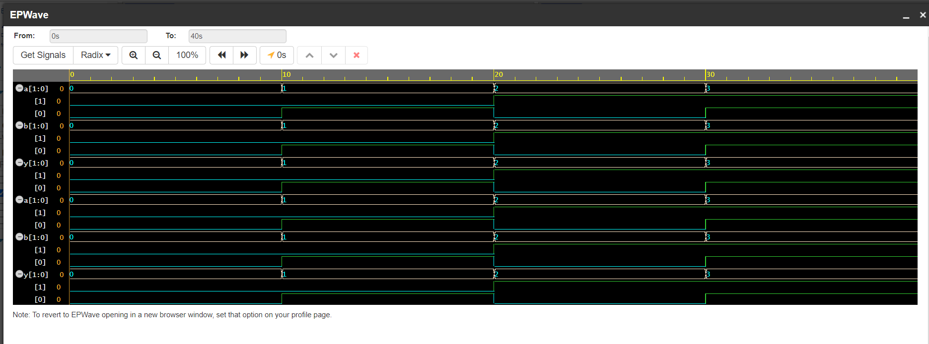

(3)

2-bits OR gate

module or_gate_2bit (

input [1:0] a, b,

output [1:0] y

);

assign y = a | b;

endmodule

module test_or_gate_2bit;

reg [1:0] a, b;

wire [1:0] y;

or_gate_2bit uut (

.a(a),

.b(b),

.y(y)

);

initial begin

$dumpfile("or_gate_2bit.vcd");

$dumpvars(0, test_or_gate_2bit);

// Test all cases

a = 2'b00; b = 2'b00; #10;

a = 2'b01; b = 2'b01; #10;

a = 2'b10; b = 2'b10; #10;

a = 2'b11; b = 2'b11; #10;

$finish;

end

endmodule

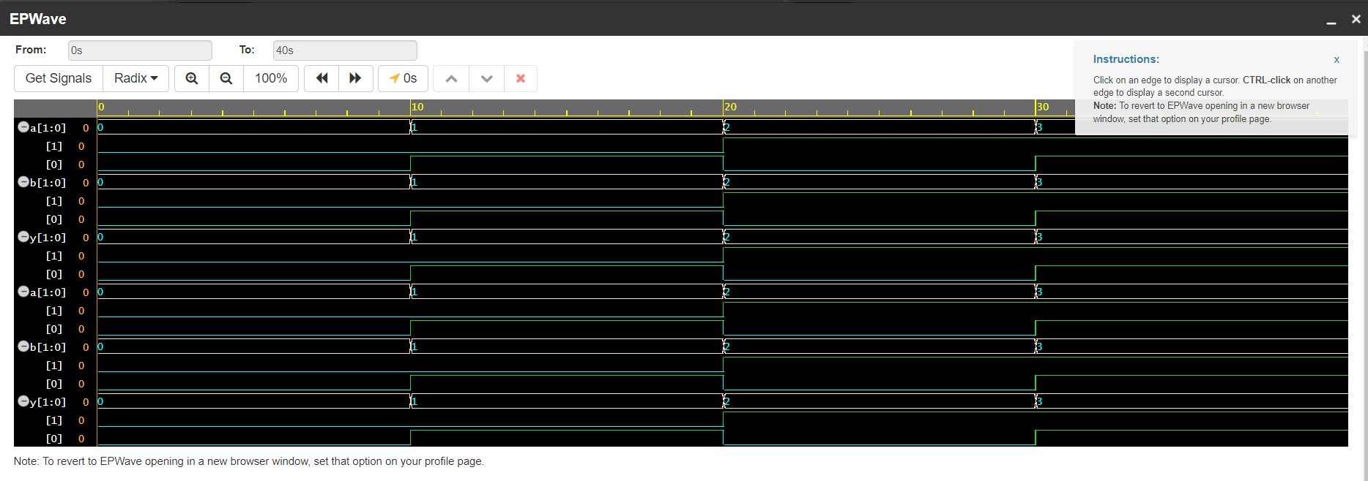

(4)

1. bits NAND gate

module nand_gate_2bit (

input [1:0] a, b,

output [1:0] y

);

assign y = ~(a & b);

endmodule

module test_nand_gate_2bit;

reg [1:0] a, b;

wire [1:0] y;

nand_gate_2bit uut (

.a(a),

.b(b),

.y(y)

);

initial begin

$dumpfile("nand_gate_2bit.vcd");

$dumpvars(0, test_nand_gate_2bit);

// Test cases

a = 2'b00; b = 2'b00; #10;

a = 2'b01; b = 2'b01; #10;

a = 2'b10; b = 2'b10; #10;

a = 2'b11; b = 2'b11; #10;

$finish;

end

endmodule

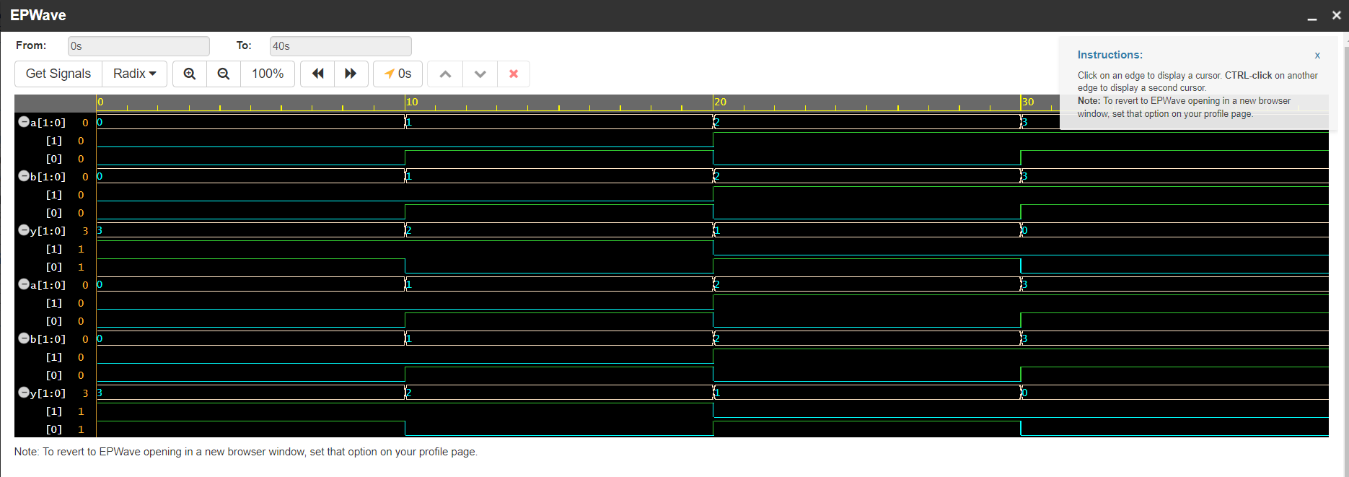

(5)

1. bits NOR gate

module nor_gate_2bit (

input [1:0] a, b,

output [1:0] y

);

assign y = ~(a | b);

endmodule

module test_nor_gate_2bit;

reg [1:0] a, b;

wire [1:0] y;

// Instantiate the NOR gate module

nor_gate_2bit uut (

.a(a),

.b(b),

.y(y)

);

initial begin

$dumpfile("nor_gate_2bit.vcd"); // For VCD waveform generation

$dumpvars(0, test_nor_gate_2bit);

// Apply test cases

a = 2'b00; b = 2'b00; #10; // Expected output: y = 2'b11

a = 2'b01; b = 2'b00; #10; // Expected output: y = 2'b10

a = 2'b10; b = 2'b01; #10; // Expected output: y = 2'b00

a = 2'b11; b = 2'b11; #10; // Expected output: y = 2'b00

$finish;

end

endmodule

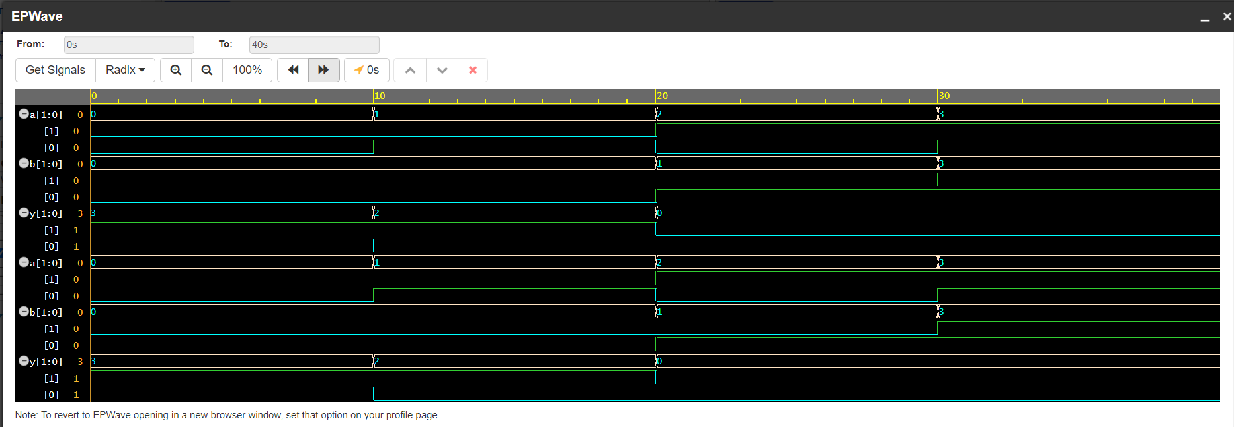

(6)

2-bits XOR gate

module xor_gate_2bit (

input [1:0] a, b,

output [1:0] y

);

assign y = a ^ b;

endmodule

module test_xor_gate_2bit;

reg [1:0] a, b;

wire [1:0] y;

// Instantiate the XOR gate module

xor_gate_2bit uut (

.a(a),

.b(b),

.y(y)

);

initial begin

$dumpfile("xor_gate_2bit.vcd"); // For VCD waveform generation

$dumpvars(0, test_xor_gate_2bit);

// Apply test cases

a = 2'b00; b = 2'b00; #10; // Expected output: y = 2'b00

a = 2'b01; b = 2'b01; #10; // Expected output: y = 2'b00

a = 2'b10; b = 2'b01; #10; // Expected output: y = 2'b11

a = 2'b11; b = 2'b10; #10; // Expected output: y = 2'b01

$finish;

end

endmodule

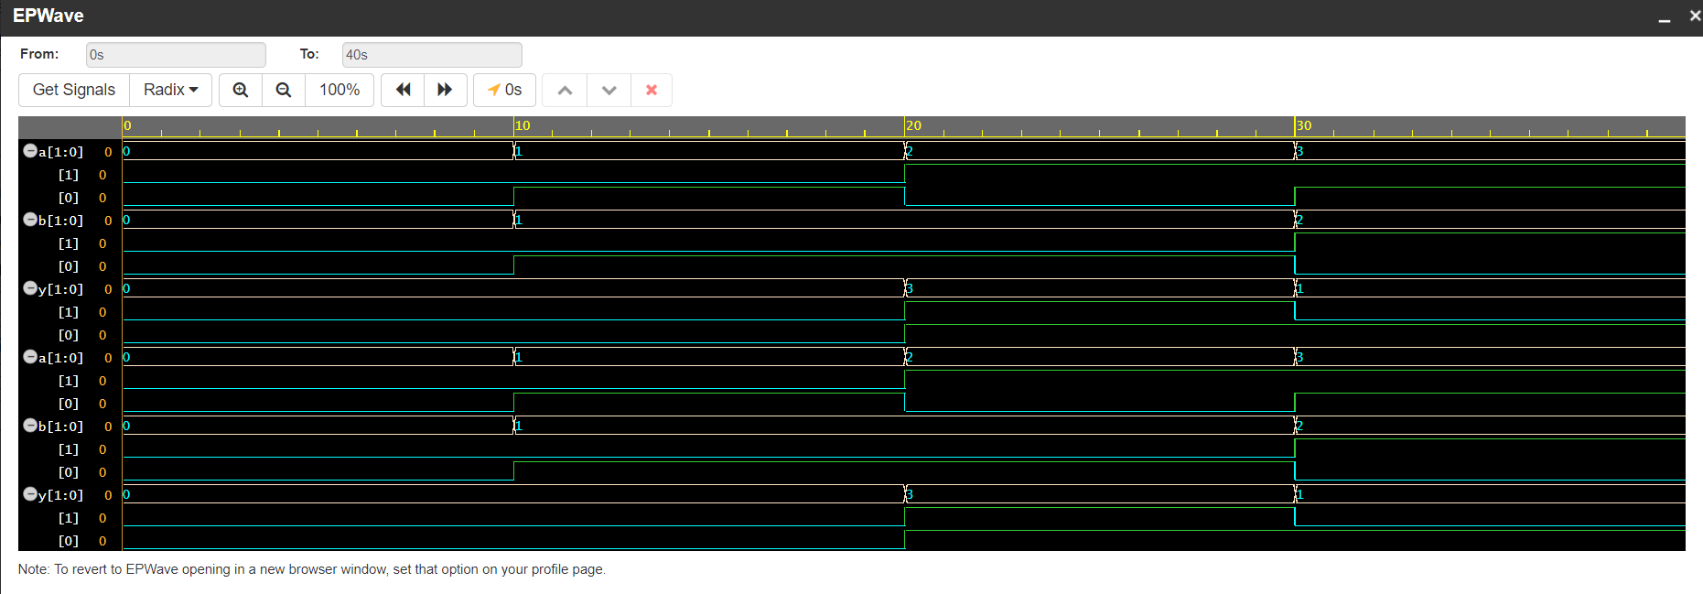

(7)

2-bits XNOR gate

module xnor_gate_2bit (

input [1:0] a, b,

output [1:0] y

);

assign y = ~(a ^ b);

endmodule

module test_xnor_gate_2bit;

reg [1:0] a, b;

wire [1:0] y;

// Instantiate the XNOR gate module

xnor_gate_2bit uut (

.a(a),

.b(b),

.y(y)

);

initial begin

$dumpfile("xnor_gate_2bit.vcd"); // For VCD waveform generation

$dumpvars(0, test_xnor_gate_2bit);

// Apply test cases

a = 2'b00; b = 2'b00; #10; // Expected output: y = 2'b11

a = 2'b01; b = 2'b01; #10; // Expected output: y = 2'b11

a = 2'b10; b = 2'b01; #10; // Expected output: y = 2'b00

a = 2'b11; b = 2'b10; #10; // Expected output: y = 2'b10

$finish;

end

endmodule

